**CS359 - Computer Network Lab**

**Lab 3**

**Socket Programming**

Tarusi Mittal 1901CS65

For this lab, we need to have a server and a client side. So I have taken the virtual machine to be the serve and my computer to be the client. So for that we set the network settings of our virtual machine to bridged adapter.

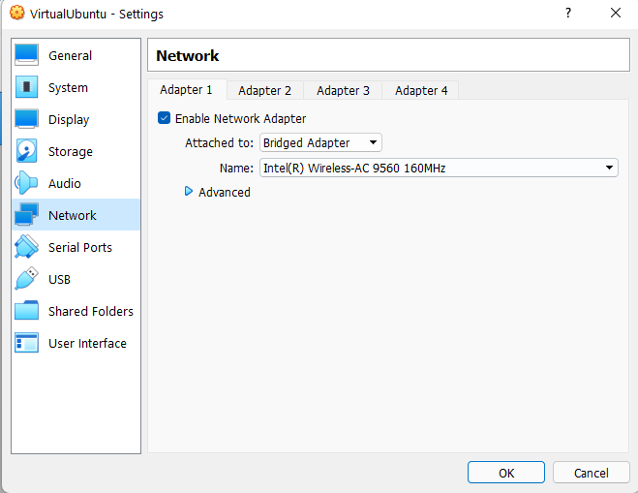

Now we will run our virtual machine and follow the following steps:

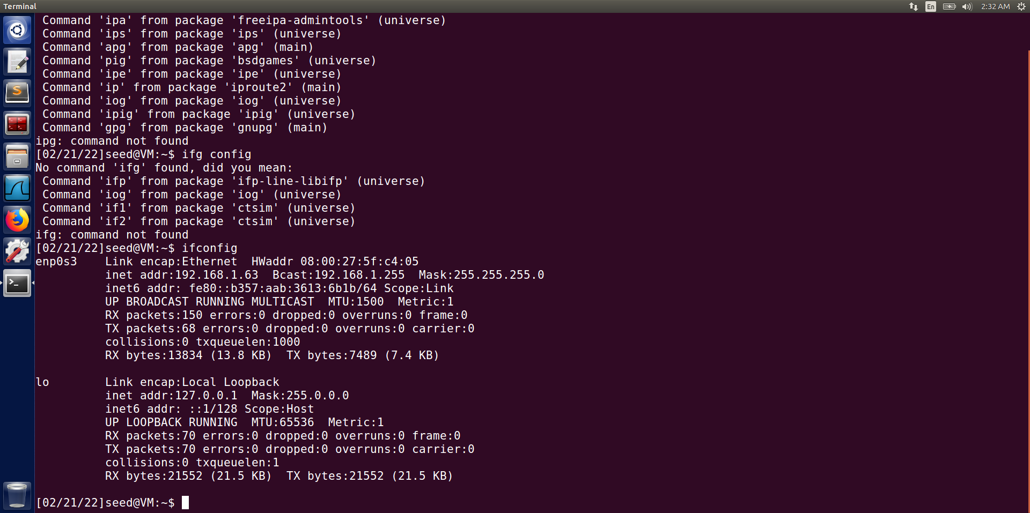

IP Address of the server

**QUESTION 1:**

**1.** We create a python file with the name server.py and insert our code of making the server into it.

We have used the port 8888, for this purpose we can use any port greater than 1024.

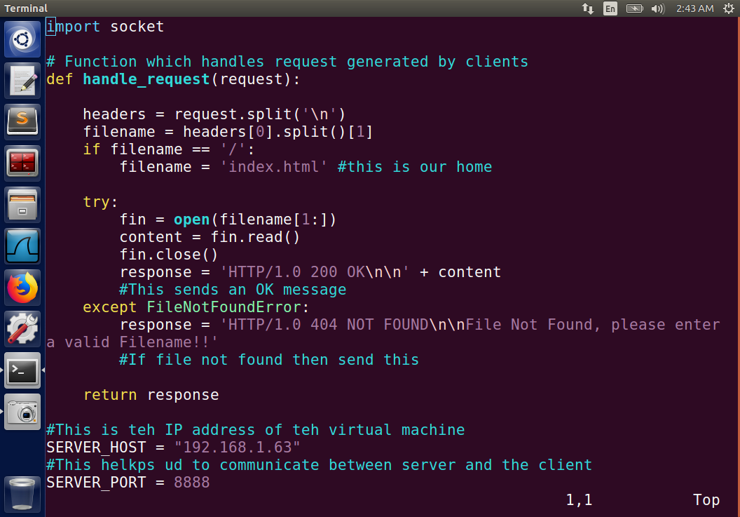

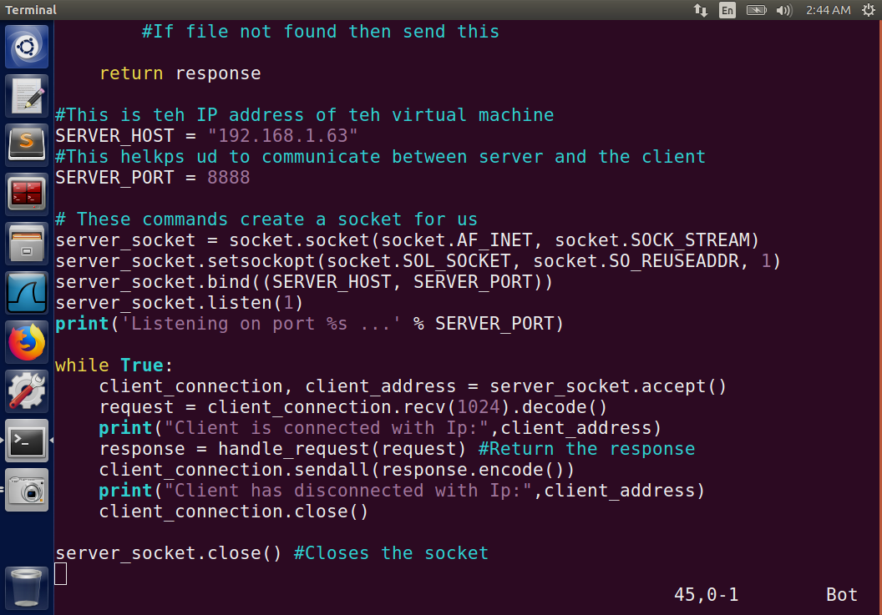

**2**. Now we make our HelloWorld.html file on this server which we will later use on our client side to access.

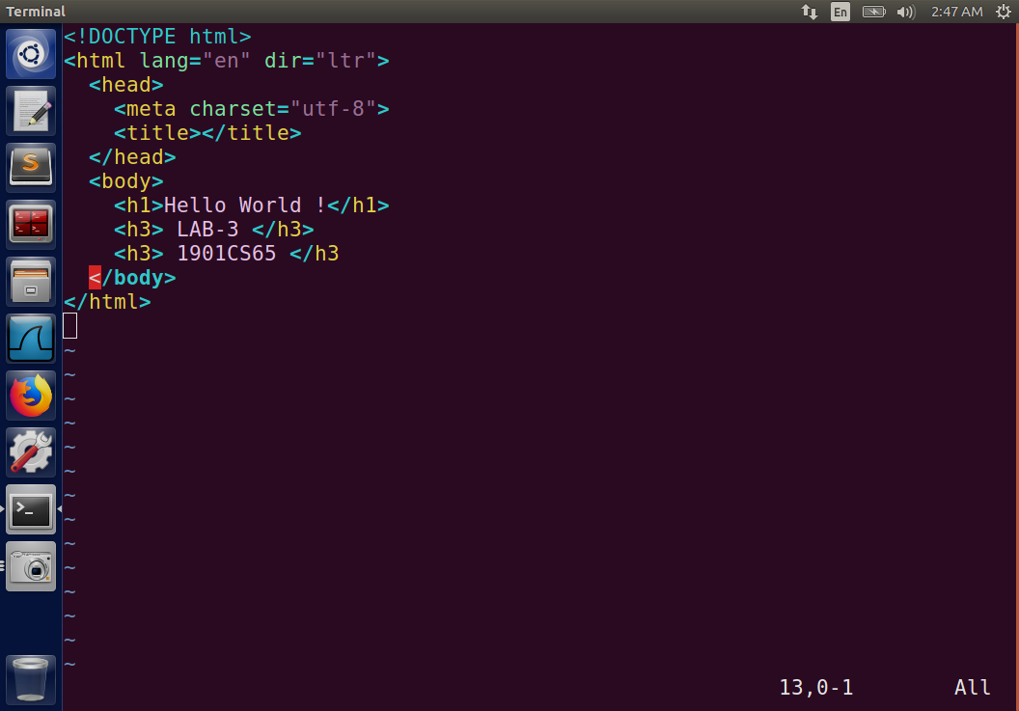

**3**. Now we will start and run our server.

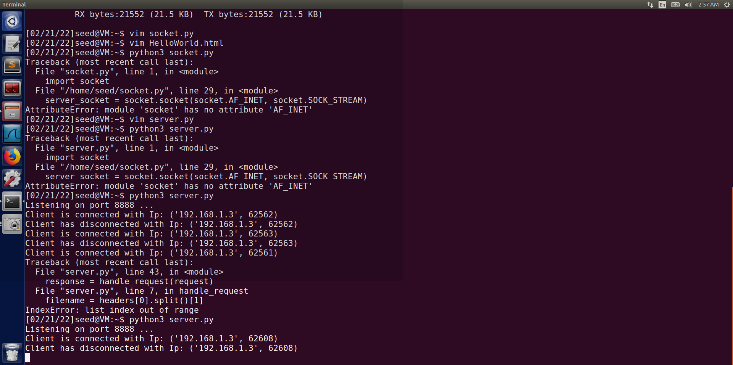

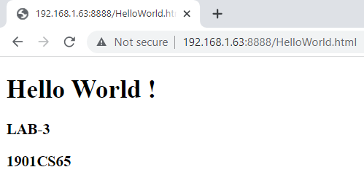

As we have entered the correct file name it opens in our browser.

4. If we enter wrong name in our browser then:

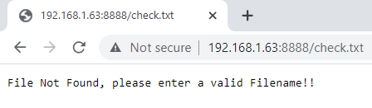

We have got the error of file not found.

5. Now in the above examples we have specified our port 8888.

Let us see the case when our port is not defined and we simply write 192.168.1.63.

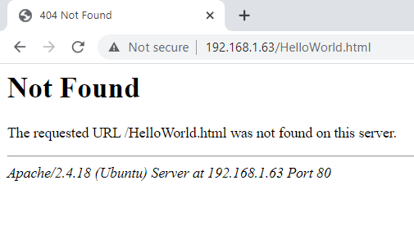

In this case we have got our error 404 of file not found. Because if we don’t specify the port the default port taken by our system in port 80.

**QUESTION 2:**

In this question we want to establish multi connection with from the client side.

There we first make the following files.

**1.** **make_config.py**: This file will make the json configuration file for us by the name configuration.json. In this file we specify a default page which is our index.html, our blocked id’s which can be changed anytime, and our maximum number of concurrent sessions allowed.

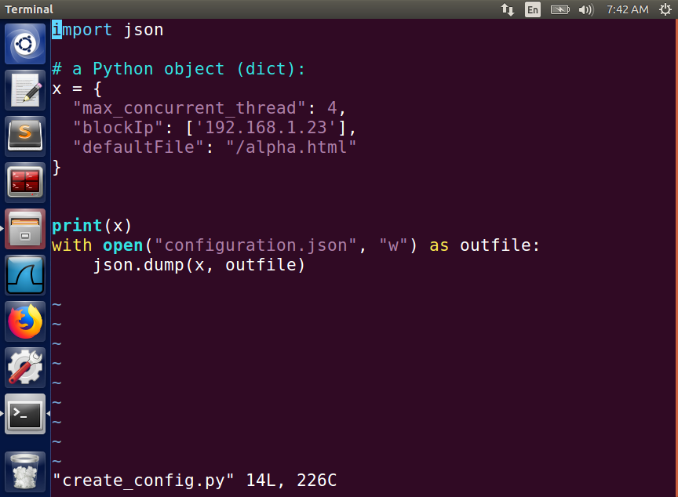

**2**. **alpha.html:** This is our default file which we had made where basically we land

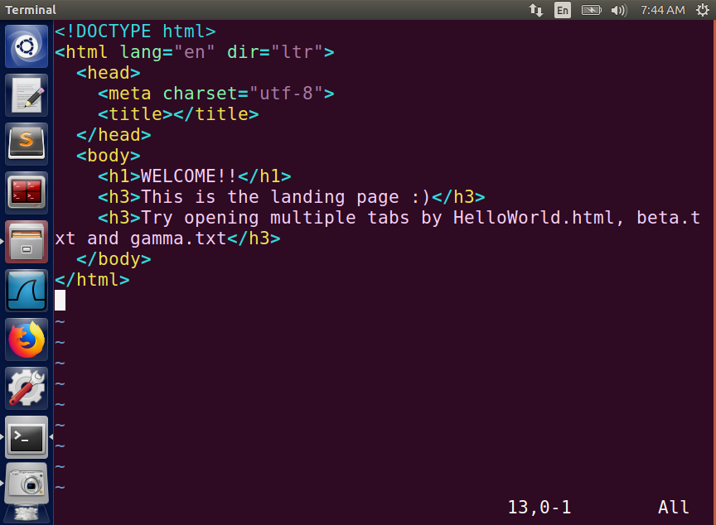

**3. HelloWorld.html:** A file to open on the client side. Same as question 1.

**4. beta.txt:** A file to open on the client side

**5. gamma.txt:** A file to open on the client side

**5. multipletabs.py:** It sets up the server code which will allow us to open multiple tabs on our client side.

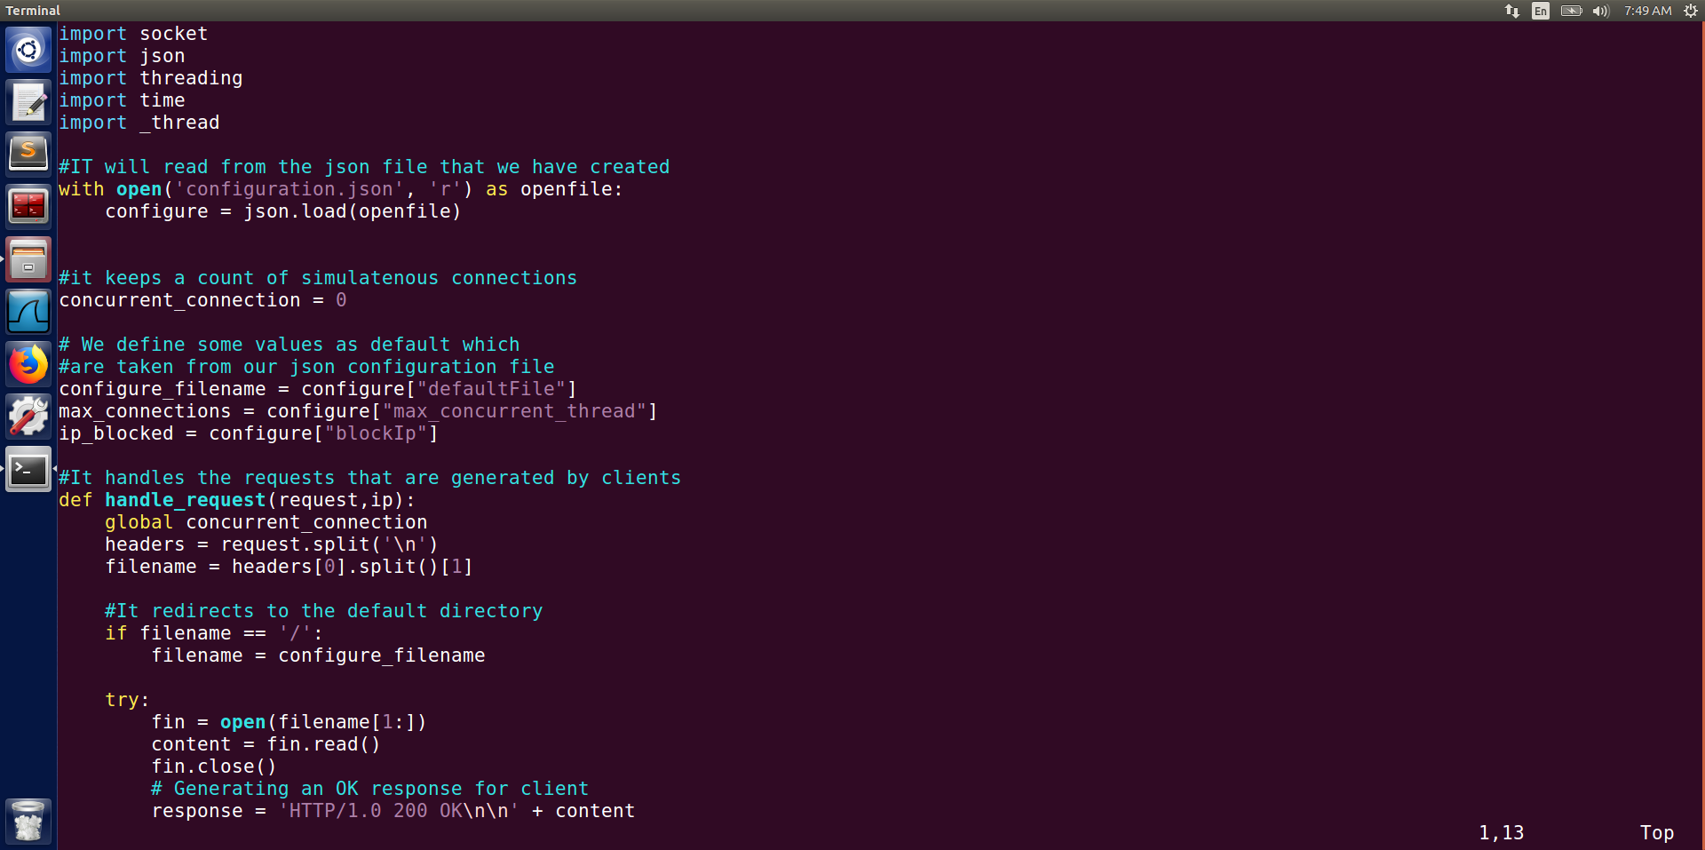

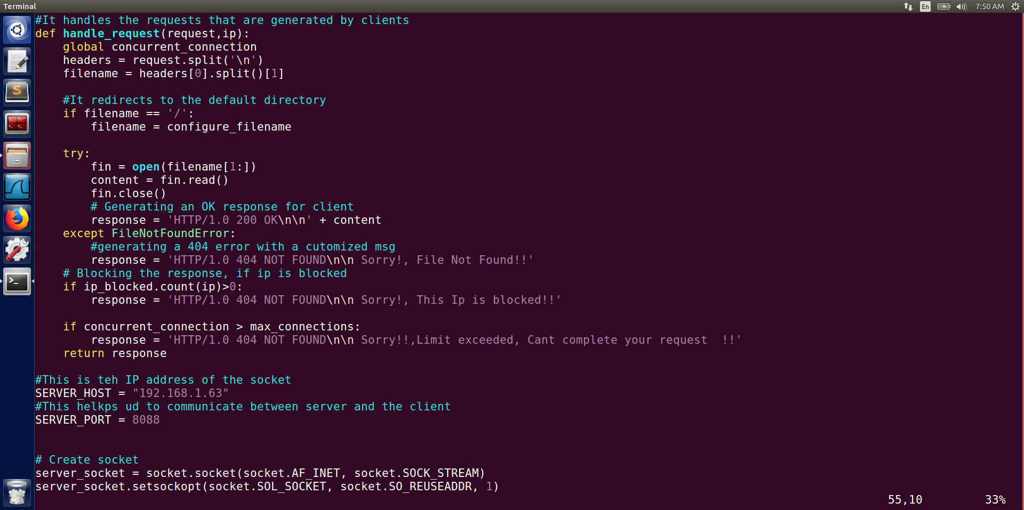

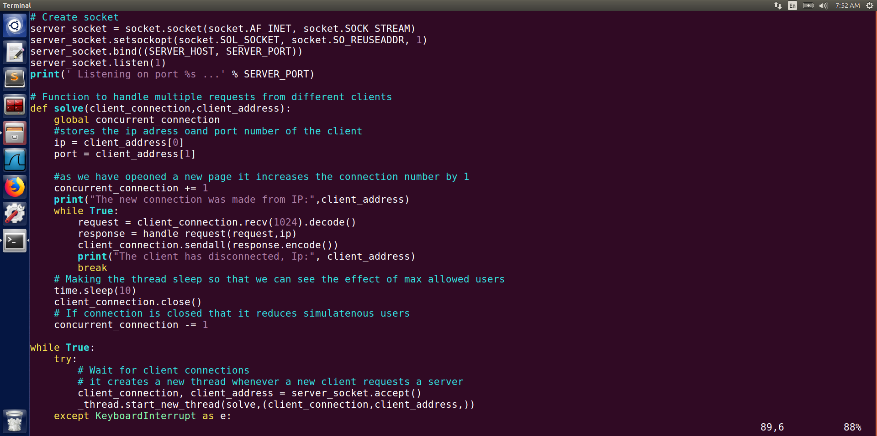

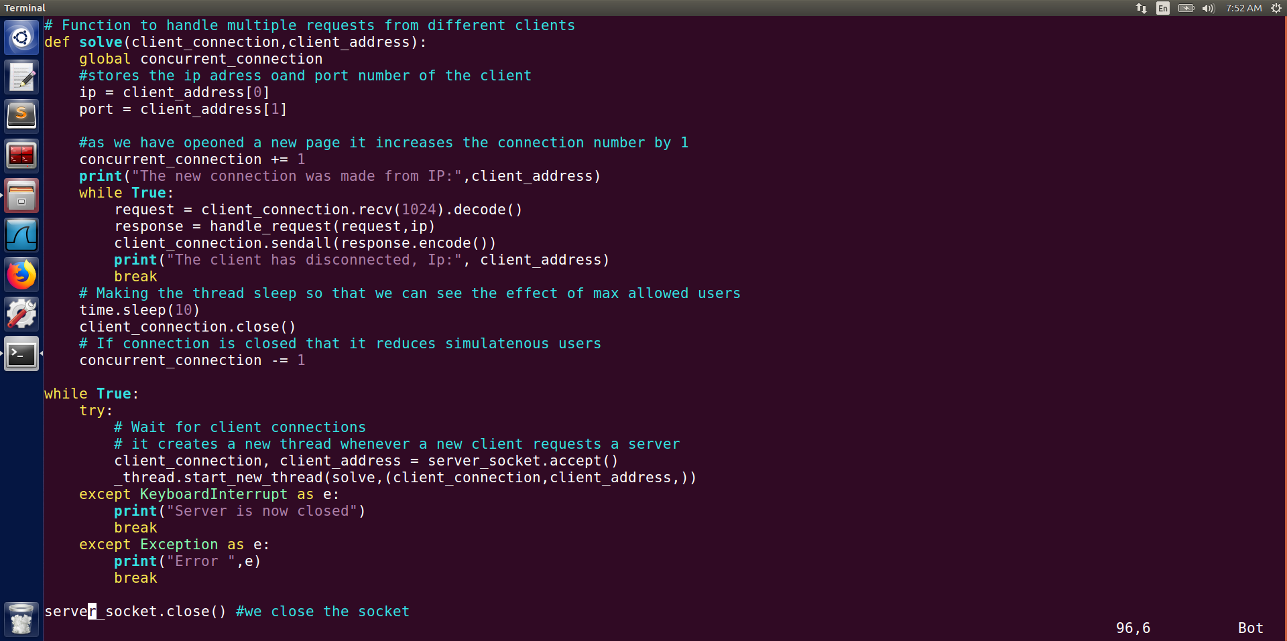

This completes our file making process and now we will run the server code and will try opening different tabs

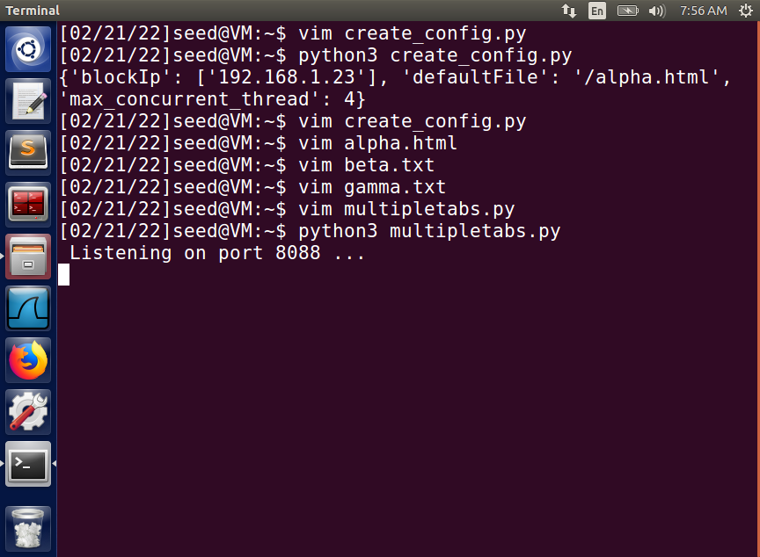

First we will open the link without specifying any file name to see if our default values are working which we have specified in our config file.

We have used the port 8088 for this.

As we can see without specifying any file name we landed at our default page.

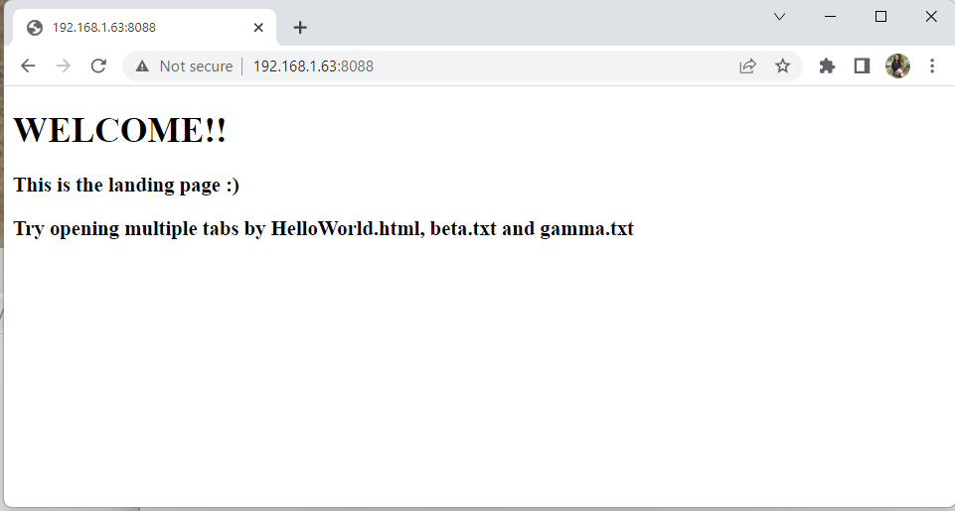

We try to open 4 tabs as is the maximum no as specified by our config.

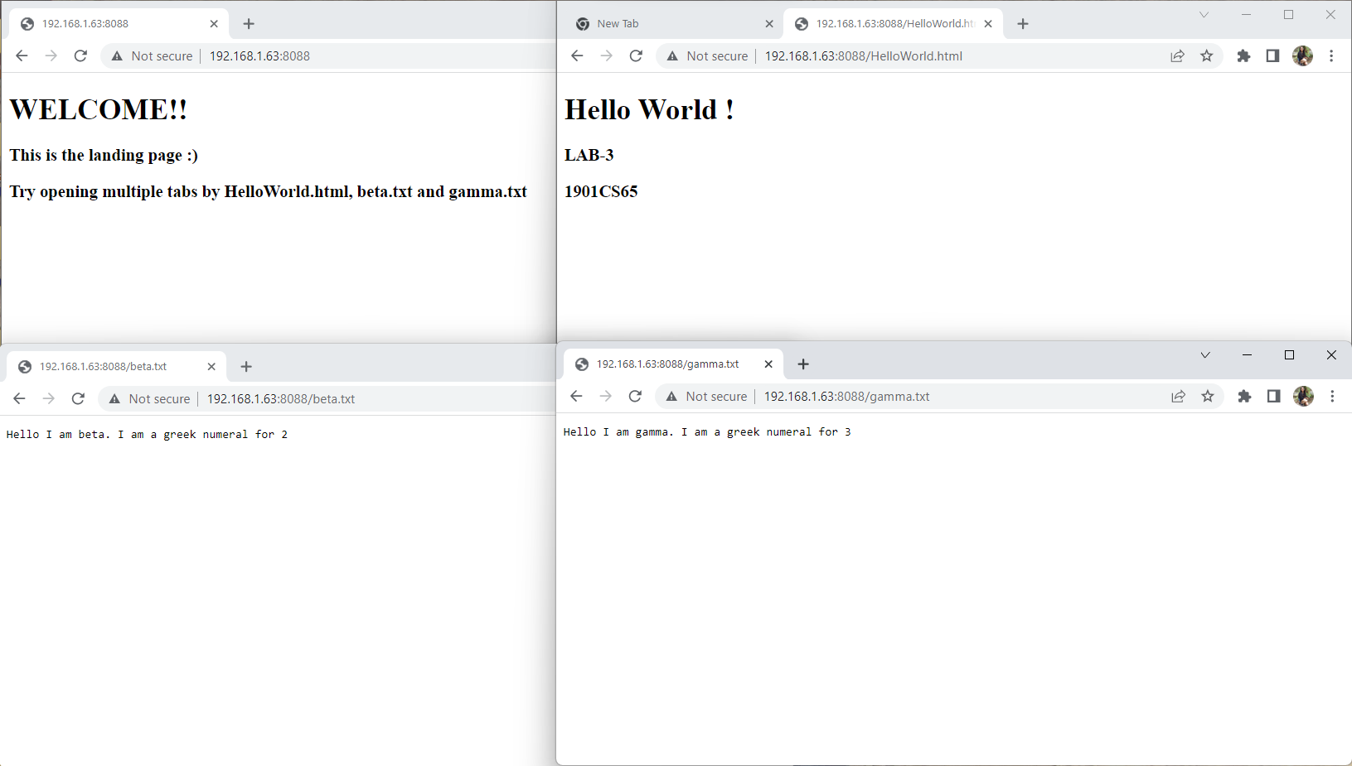

This is what our terminal looks like when we have made 4 requested

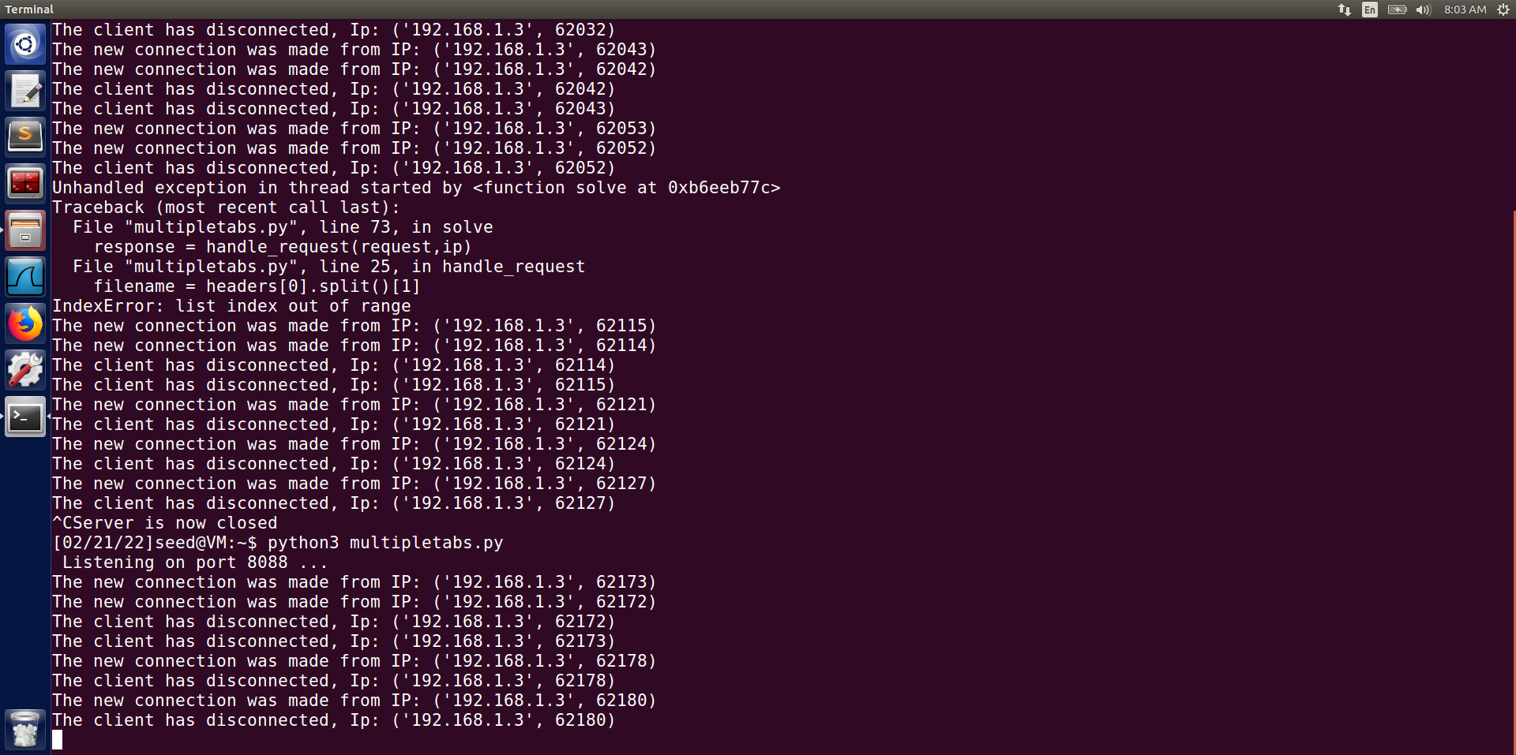

Now as our maximum no of tabs that can be opened simultaneously were 4. So we now open 5 tabs to check if our server is giving appropriate response:

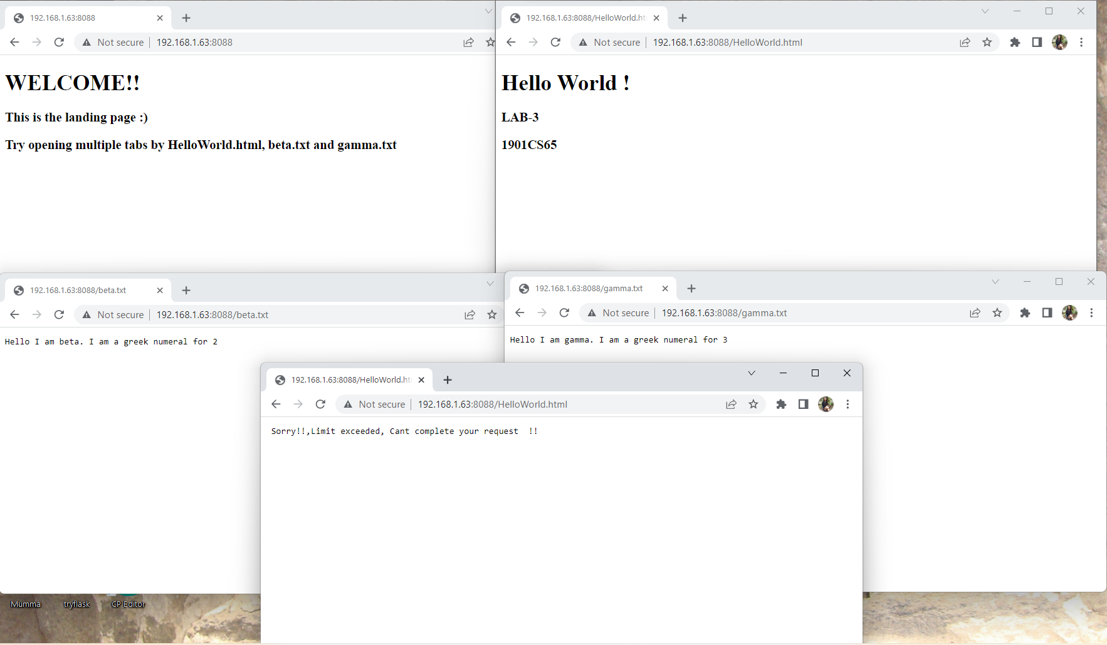

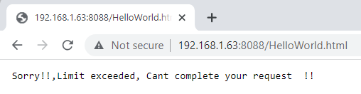

Now we will see what if we add our windows Ip address to the blockIP Addresses list.

For that we first need to find the IP address of our device:

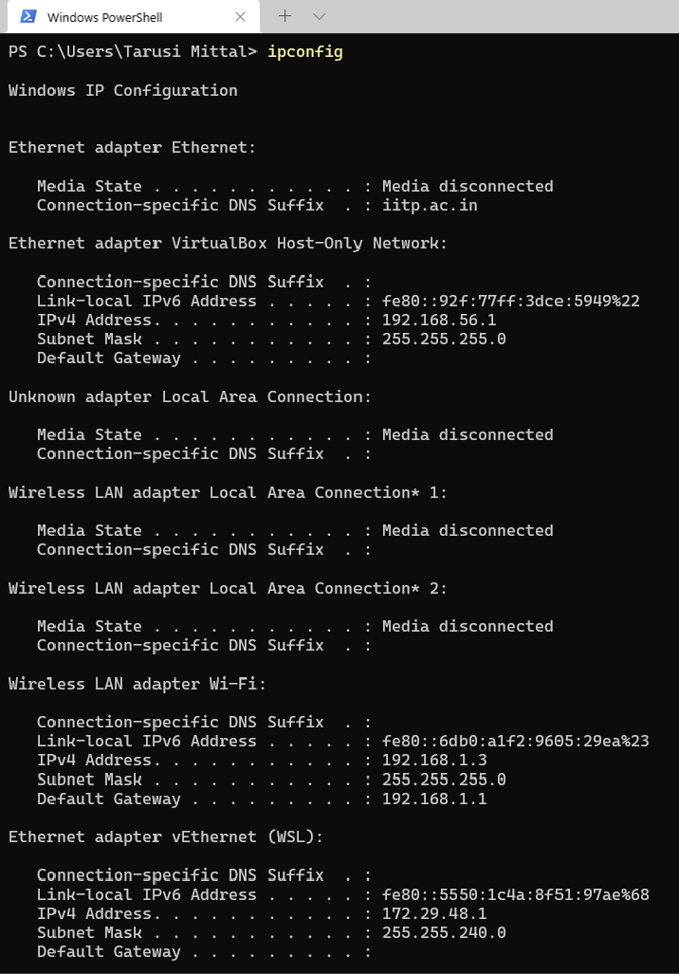

Required IP Address for our purpose.

After finding the IP address, we change our config file to add the required IP address.

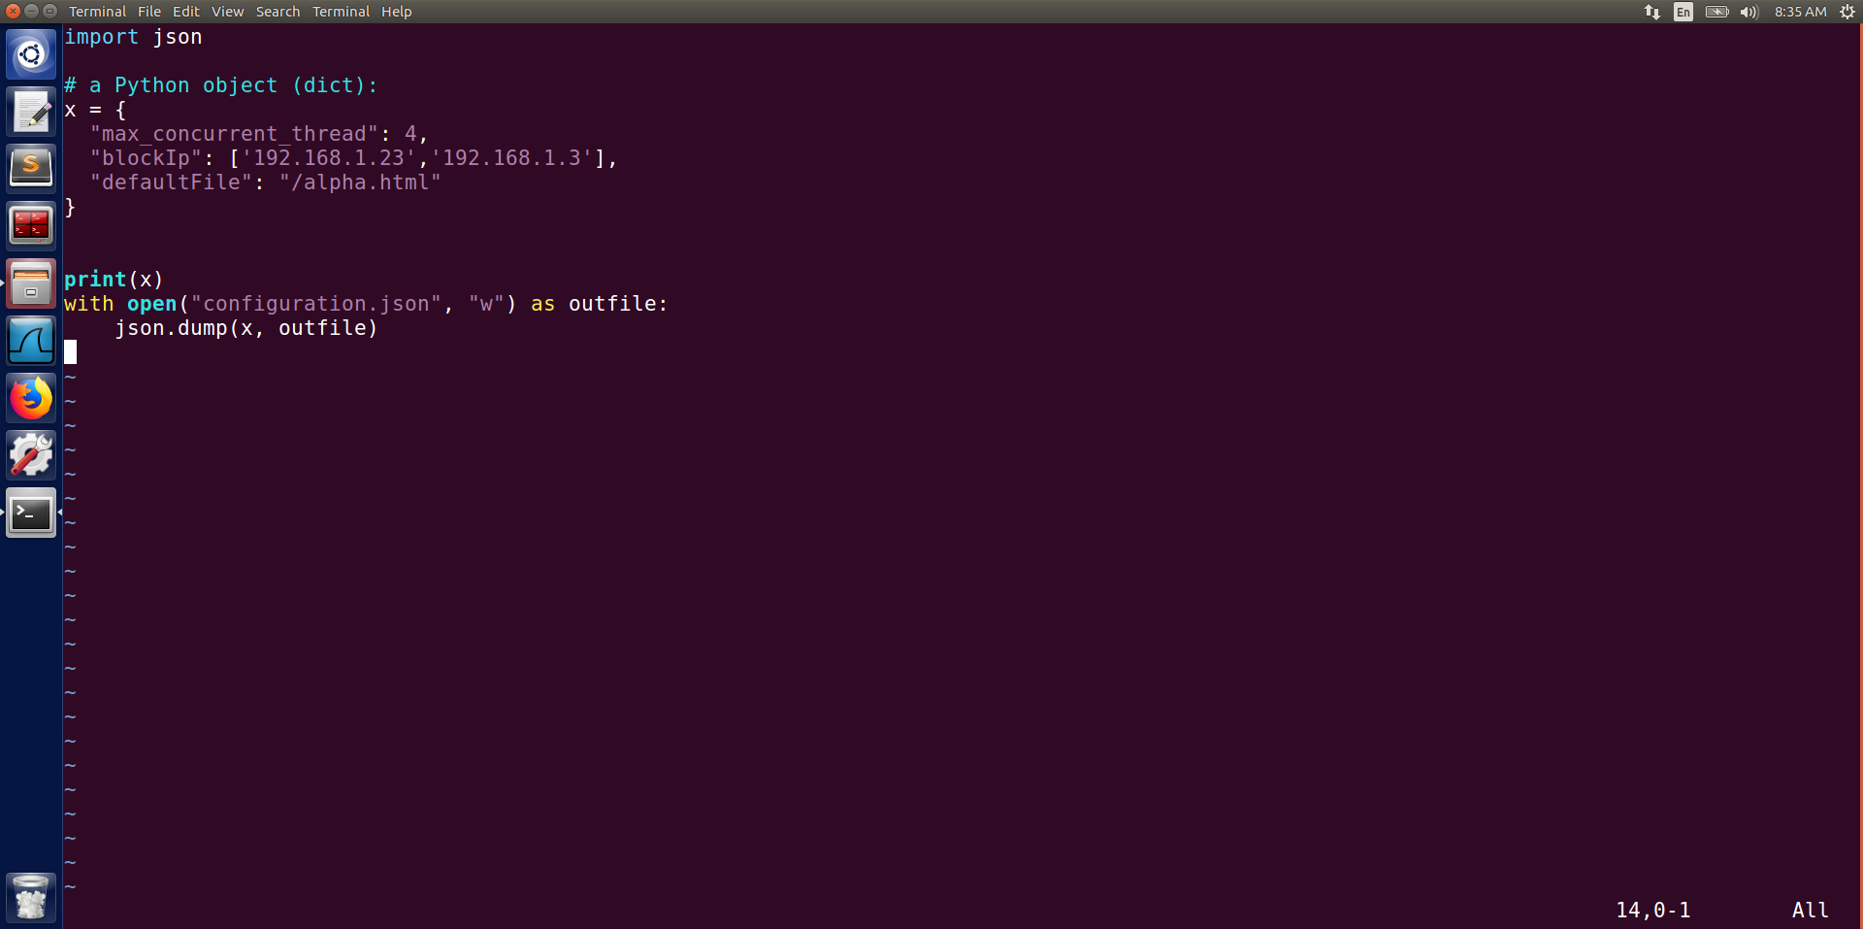

We deploy our config code and start the server.

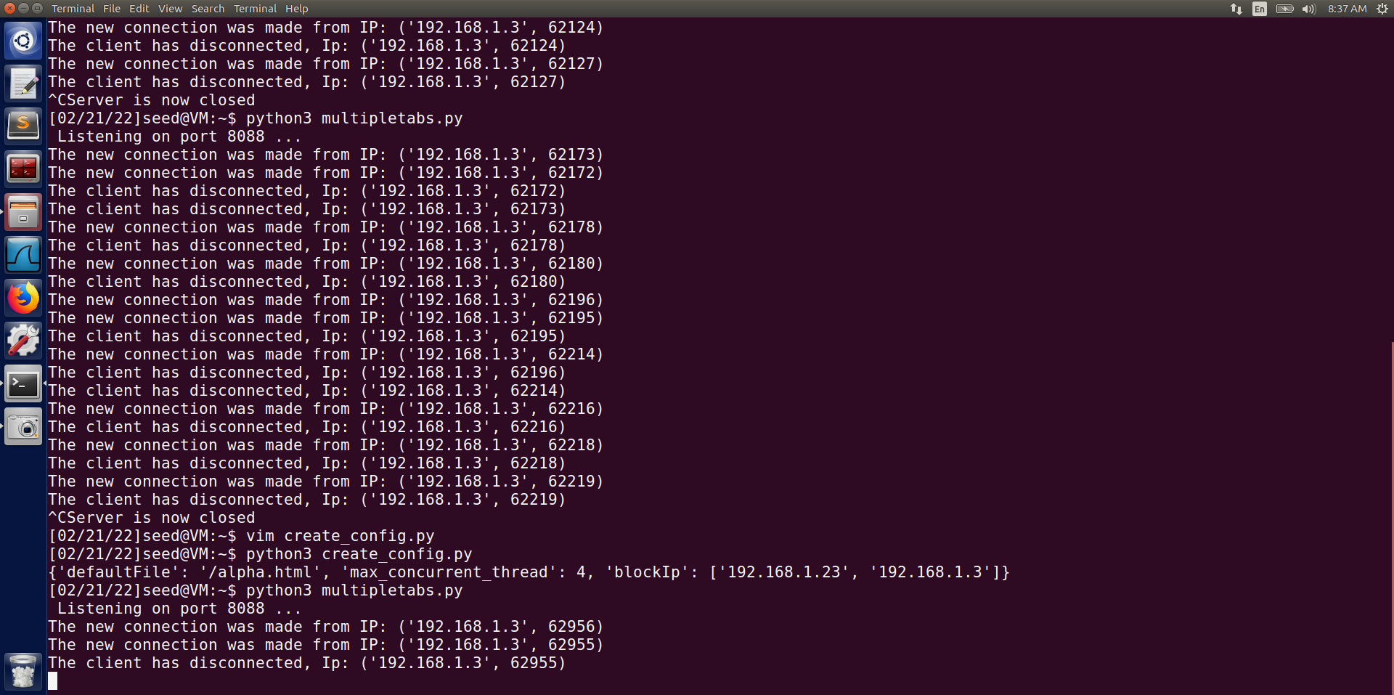

As we can see when we now try to access it from our windows client we get the error of IP Blocked

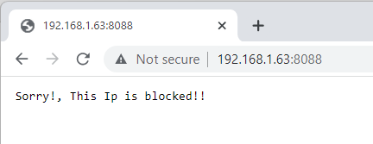

But if we try to run our page from the virtual machine itself we can see that we are able to run it, since its address was not in the block list.

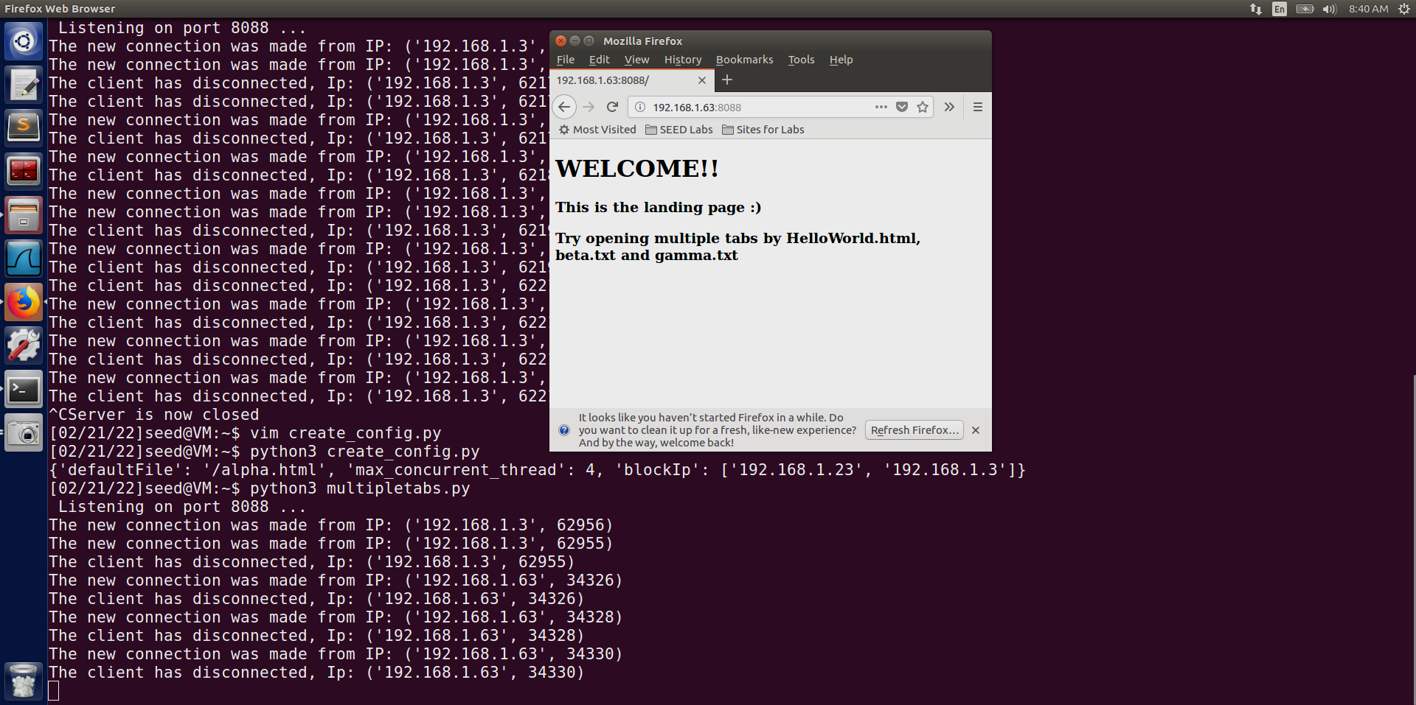

Virtual Machine Client

Window Client

Also on the terminal we can see the requests being generated from both the windows and the virtual machine.

END